AFEN ORLENO SUPRIYADIN

L200180208

*FCFS

|  |  |  |  |  |
| --- | --- | --- | --- | --- |
| Proses | Interval time | Burs time | Service time | Priority |
| p0 | 0 | 7 | 0 | 4 |
| p1 | 1 | 3 | 7 | 22 |
| P2 | 2 |  |  | 1 |
| p3 | 3 | 2 | 20 | 3 |

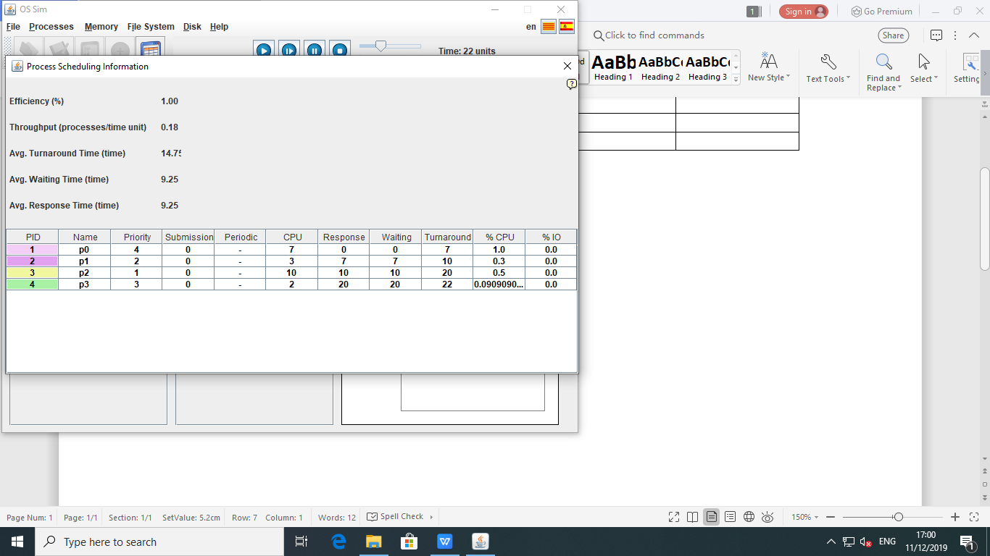

|  |  |
| --- | --- |
| Proces | Wait time |
| P0 | 7 |
| P1 | 3 |
| P2 | 10 |
| P3 | 2 |
| Avg.truns time | 14.25 |
| Avg.Waiting time | 9.25 |
| Avg.Respon time | 9.25 |

*SJFS

Premtive:

|  |  |
| --- | --- |
| Proses | Wait time |
| P0 | 7 |
| P1 | 3 |
| P2 | 10 |
| P3 | 2 |
| Avg.truns time | 10.25 |
| Avg.Waiting time | 4.75 |
| Avg.respon time | 4.75 |

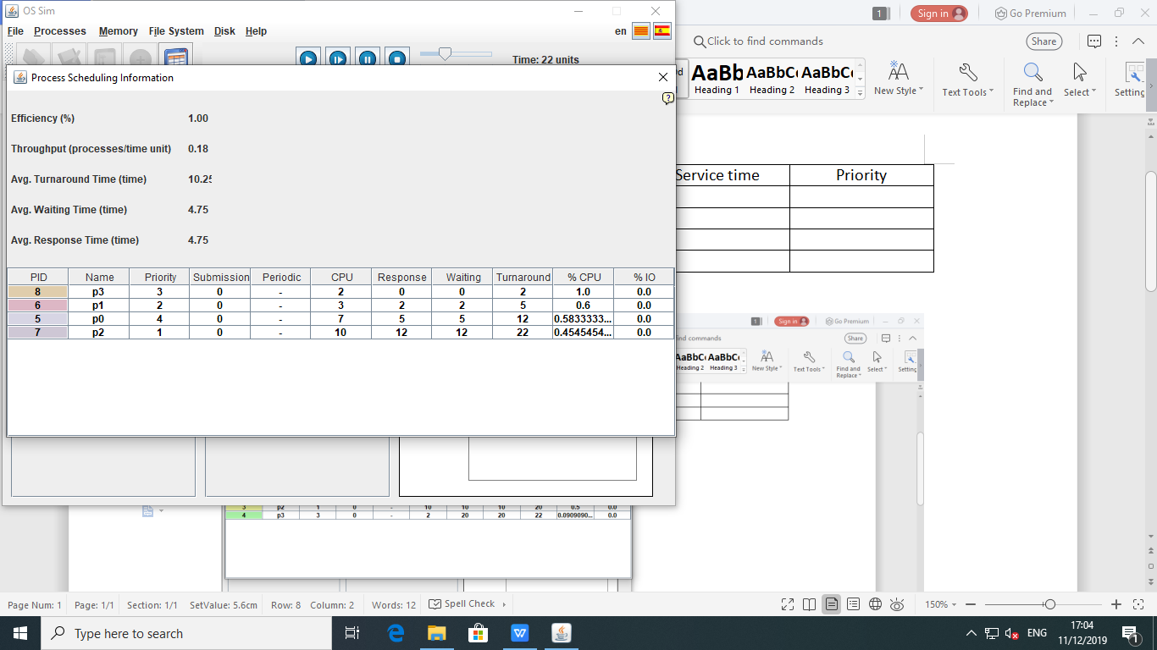

*NON Premtive

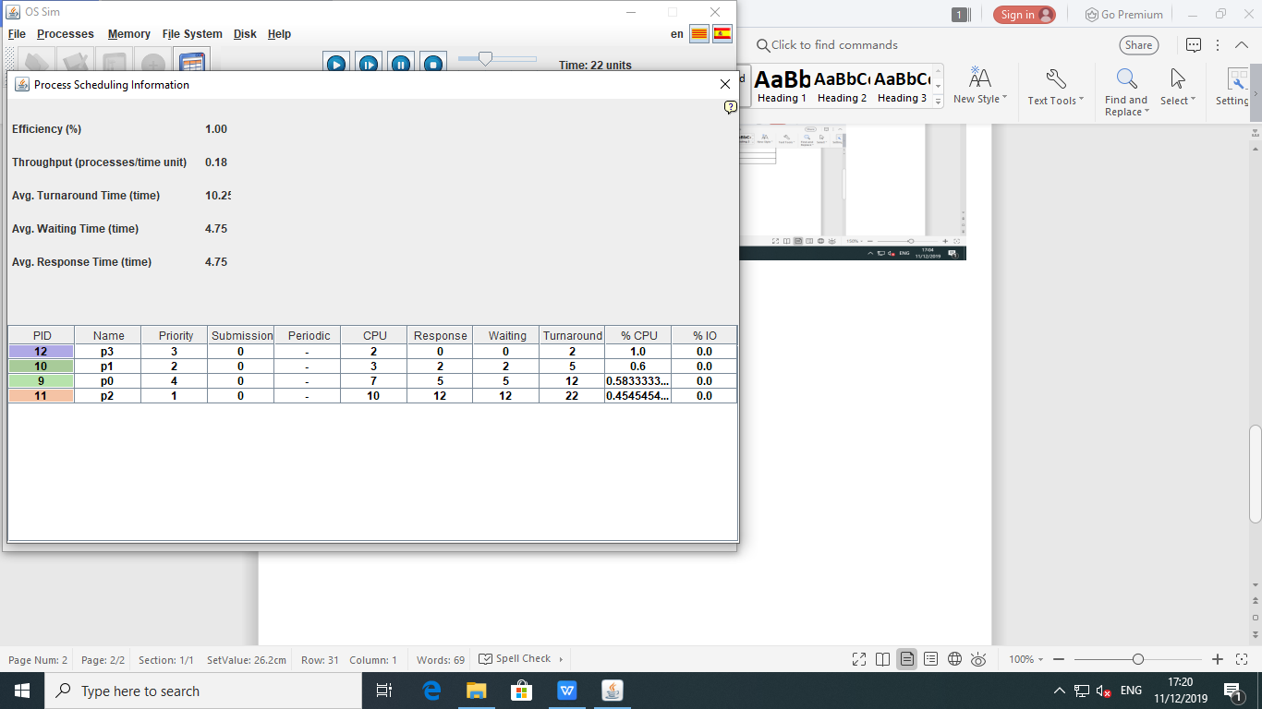

|  |  |
| --- | --- |
| Proses | Wait time |
| P0 | 7 |
| P1 | 3 |
| P2 | 10 |
| P3 | 2 |
| Avg.truns time | 10.25 |
| Avg.wating time | 4.75 |
| Avg.respon time | 4.75 |

*PRIORITY SEDULING

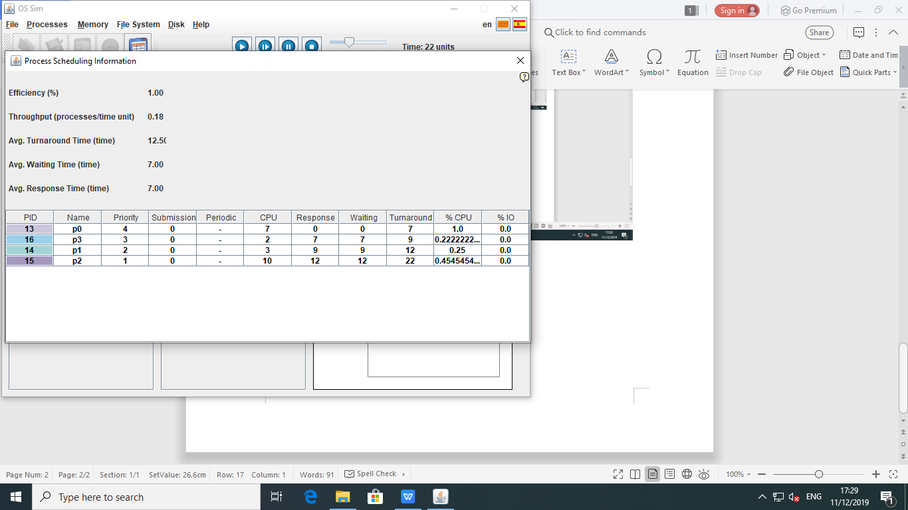

|  |  |
| --- | --- |
| Proses | Wait time |
| P0 | 7 |
| P1 | 3 |
| P2 | 10 |
| P3 | 2 |
| Avg.truns time | 10.75 |
| Avg.Waiting time | 7.0 |
| Avg.respon time | 7.0 |

*Round Robin

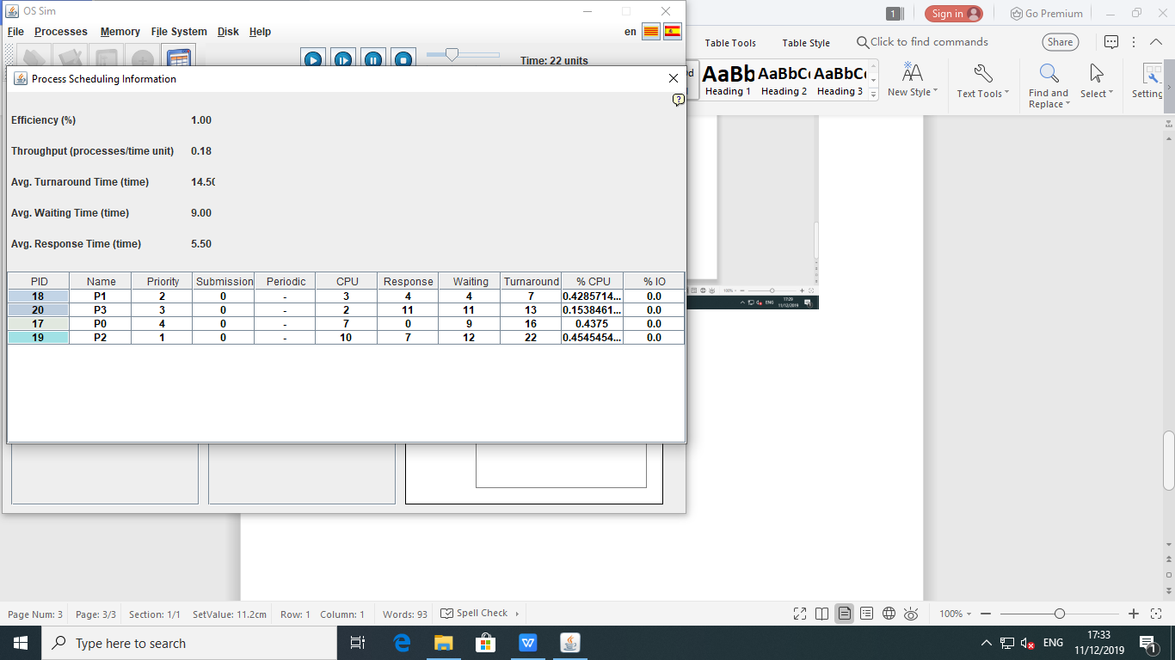

|  |  |
| --- | --- |
| proses | Wait time |
| P0 | 7 |
| P1 | 3 |
| P2 | 10 |
| P3 | 2 |
| Avg.turn time | 14.50 |
| Avg.waiting time | 9.0 |
| Avg.respon time | 9.0 |